**Problem 1**

B-P

C-P

**C**

**A**

3

**P**

**B**

3

A

C

30 mm

20 mm

50 mm

A-P

**Problem 2**

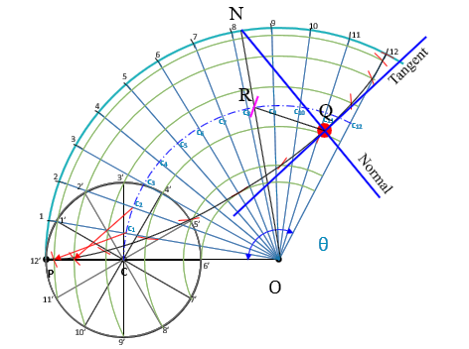

**OP = Radius of directing circle = 120 mm**

**PC = Radius of generating circle = 30 mm**

**θ = r/R x 360º = 30/120 x 360**° **= 90**°

**Problem 3**

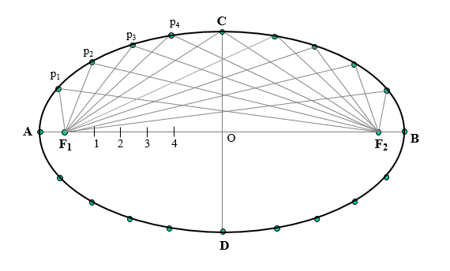

75 mm

120 mm

**Problem 4**

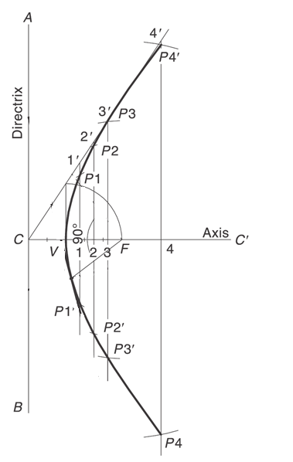

20 mm

CF = 60 mm

⸫ CV+VF = 60

e = 2

⸫ VF / CV = 2 => VF = 2 CV

⸫ 3 CV = 60

=> CV = 60 / 3 = 20 mm

60 mm